**Research Challenge 2**

nli77

The paper I chose is Active models for tracking moving objects [1]. It is a very classic early paper published on *Pattern Recognition*, back in 2000 that applied Kalman filter into the field of moving objects tracking in the video analysis field.

**Goal:** The paper aims to capture the position of the target object in the next frame, based on the knowledge acquired from previous frames, and the object prediction model. In the beginning of the process, it will generate a template image (for example a person) for the target, and later on, the model needs to dynamically track this template image in the following frames in the video(a typical example will be a person walking in the video).

**Related Parameters:** To tackle this problem, we need to positional change and size change of the target from current frame to the next frame. So that once we know the initial position and size of the target, we could predict the position and size in the next frame. According to this goal, the motion parameter could be classified into 4 groups: 1) position change from current frame to the next frame. 2) size change from current frame to the next frame 3) speed of position change (or the derivative of the positional change against time) 4) speed of size change (namely, the derivative of the size change against time).

**Methods:** This algorithm has two main modules: prediction and update 1) prediction: predicting the estimates motion parameters (position of the target centroid, size of the target, positional change of the target, size change of the target) of a target. Those parameters could be used to limit the possible area the target will likely to move to in the next frame. 2) update: update target model through energy minimization. Search the image patches within the possible area. The energy could be understood as a cost function between the template image patch and the target object. When the energy gets minimized, it finds out the model that can best match the target in terms of both color, shape, texture and edge features. And it will generate an improved model (target position change, size change) based on the update result.

**Result:** The paper used tracking walking person as the experiment. They put the camera and give the target person template for the program, and let the program tracking the person while he is walking around and his distance from the camera varied so that his size in the camera image also varied. They also let another person walk around, and the program still could recognize the target person very well.

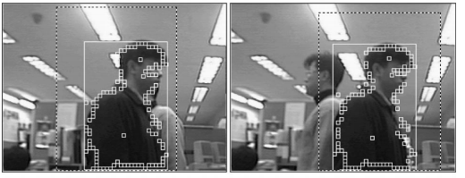

An example of walking person tracking from the paper

**Learning thoughts**: The paper most interests to me is because it is one of the papers that applied Kalman filters in the object tracking field. Usually, based on what I learned from the class and papers, it is usually applied in the signal smoothing (stock moving average line) or parameter estimates (GPS signal) field. This paper allows me to see the computer vison parameters could also be applied although it is a little bit different from the Kalman filter applications, especially in the update phases (using energy minimization to find the target in the next frame). This paper lets me know, it worth a try to apply Kalman filter to any parameter estimates field, as long as it is linear model we have a way to measure it and can update (or improve) the model.

**Reference**

1. Jang, Dae-Sik, and Hyung-Il Choi. "Active models for tracking moving objects." *Pattern Recognition* 33.7 (2000): 1135-1146.